**K8s PRACTICAL**

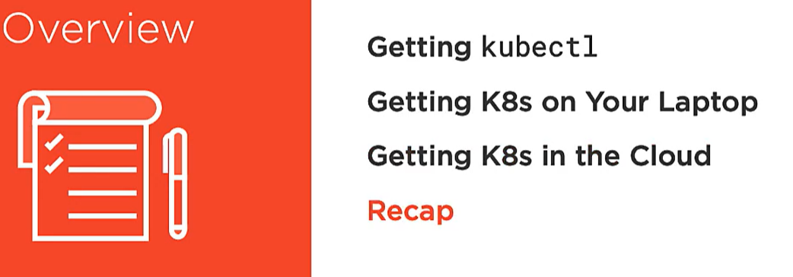

**Kubectl**

Kubectl is a command line tool to work with K8s Cluster.

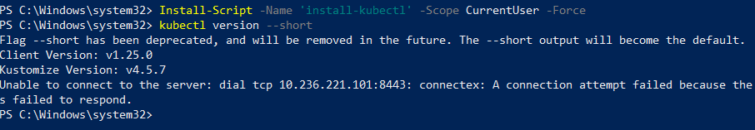

Kubectl has concept of **context:** which is a group of clusters and user on that cluster.

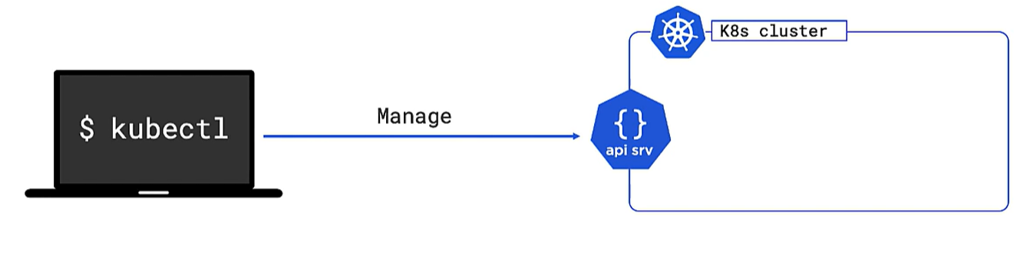

**DOCKER DESKTOP**

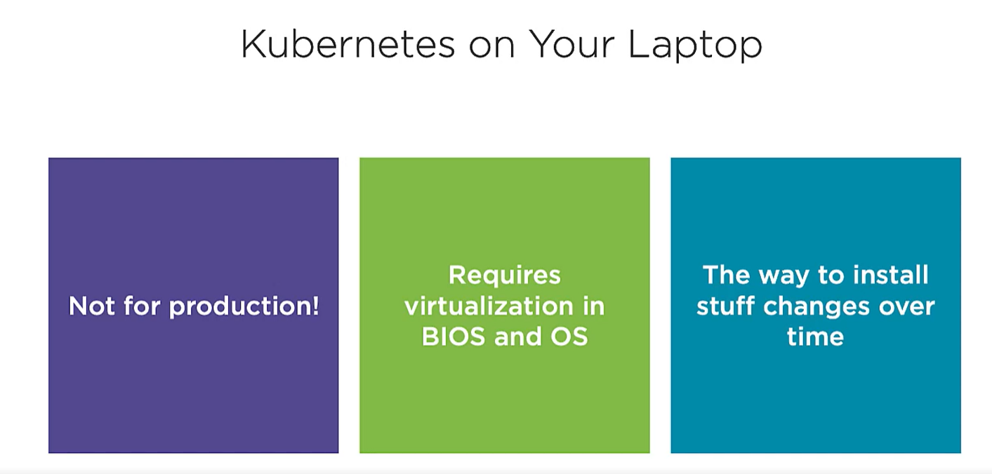

**STEPS TO CONFIGURE KUBECTL WITH DOCKER DESKTOP CLUSTER:**

* Download Kubectl client into our machine

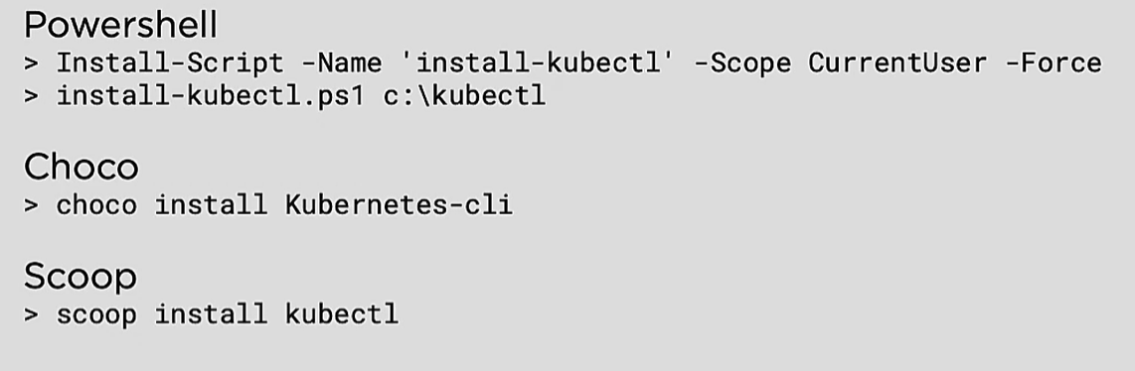

* Once we download it , it will create a .kube folder
* Start docker K8s cluster, and once it is started we can see a config file inside .kube folder.
* Now do Kubectl version –short

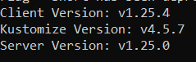

* IF server version is not shown there is some proxy issue so remove http_proxy from env variable.
* Do Kubectl get nodes and will get a master node of docker desktop.

**Client and server version should only differ by 1 version.**

**KUBERNETES ON CLOUD**

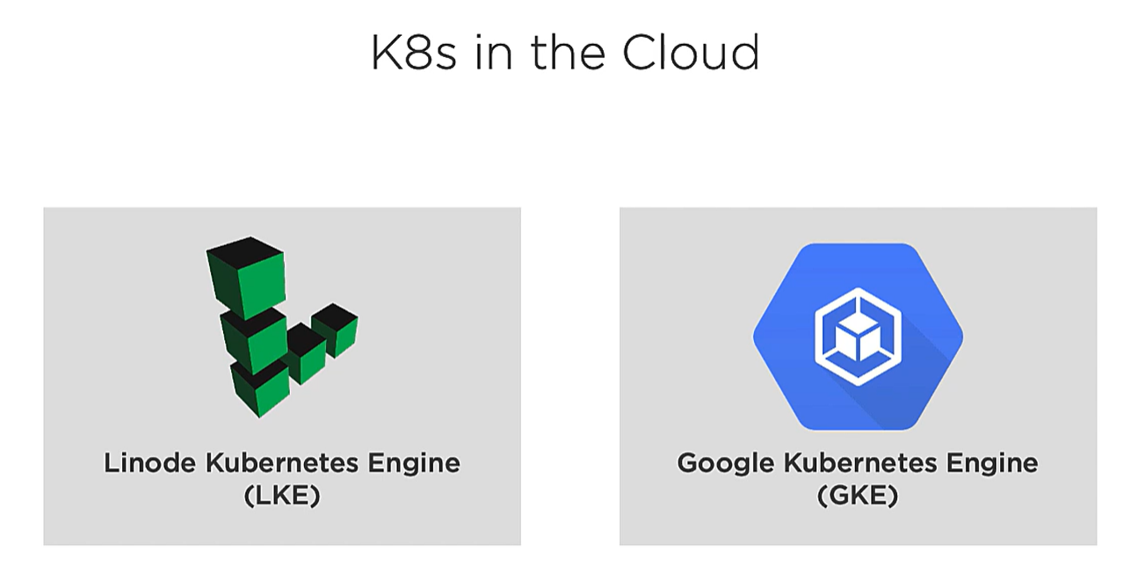

**Hosting K8s as a platform** – Helps user to just bother about the apps and all control plane related stuff is managed by Cloud host.

This demo we are using **linode** as our K8s cluster provider.

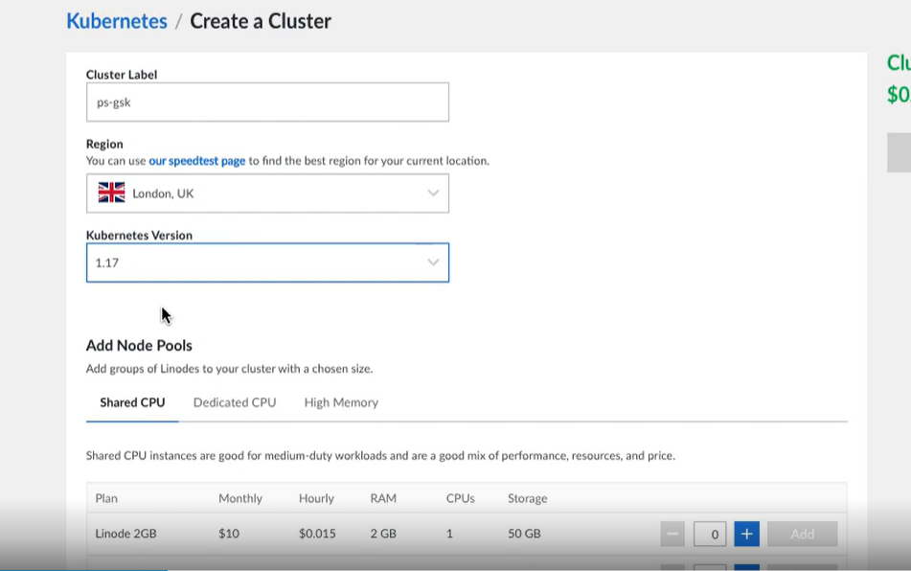

We just need to create a new cluster give it a name and select the resource package.

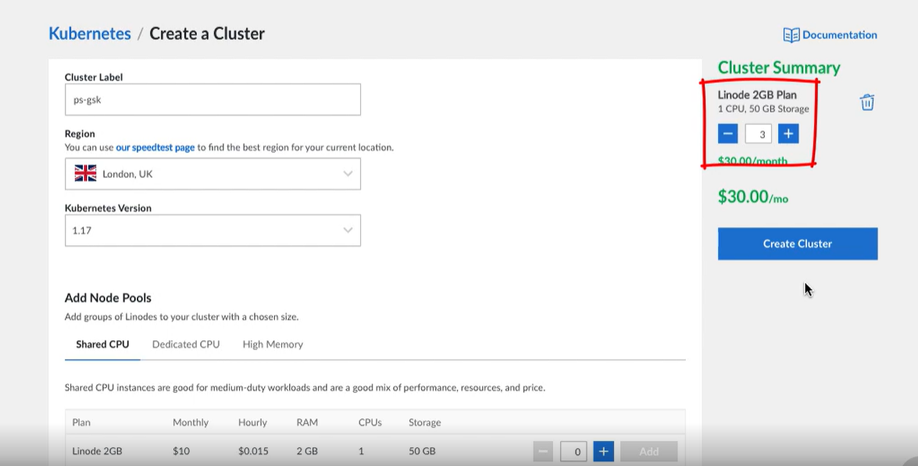

Once we select nodes resource. K8s and cloud provider will make sure we always have 3 nodes available.

Once a cluster is created we get a summary

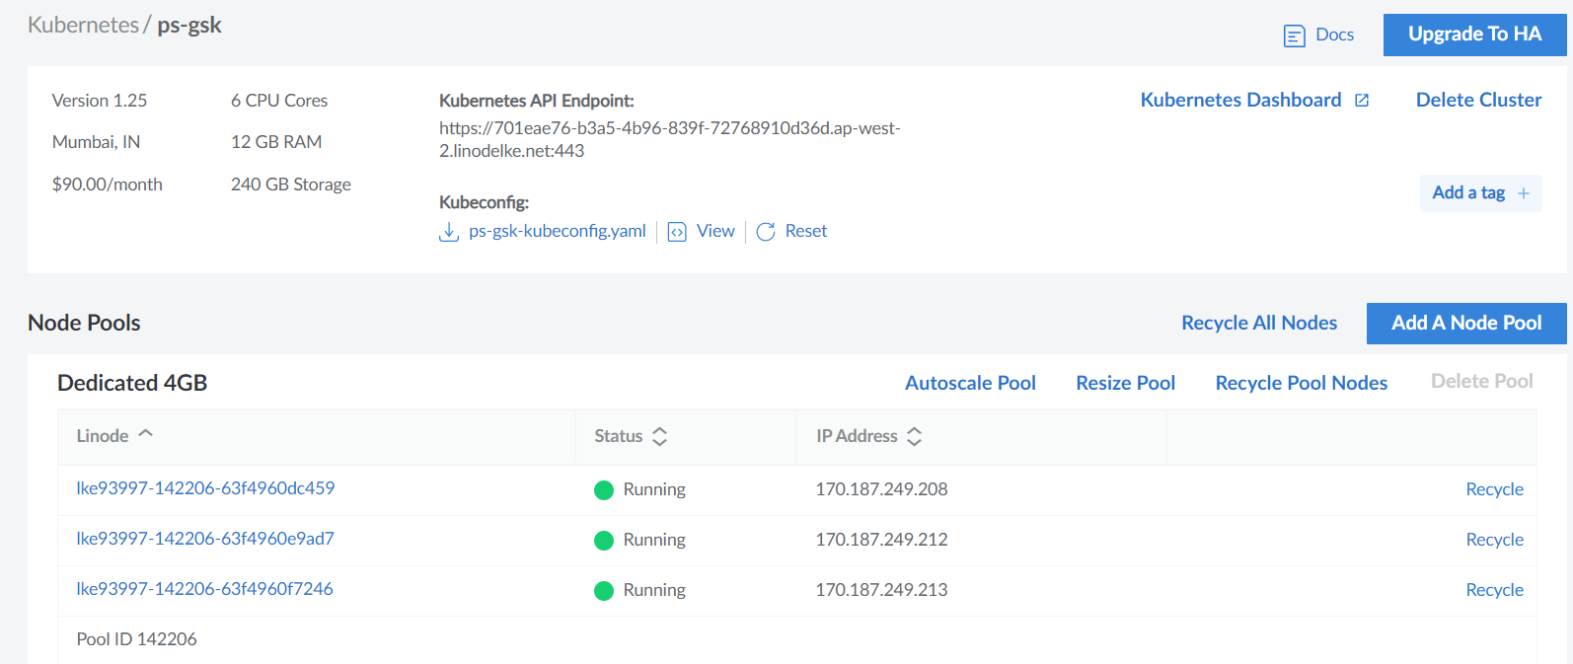

We also have a **Kube config file** so that Kubectl talks to the cluster. In order for our system Kubectl talks to this cluster we need to cut paste the cluster user and context info to our local kube-config file.

**Kube-config file will be modified as we connect to multiple K8s cluster.**

**Below is my local kube-config file**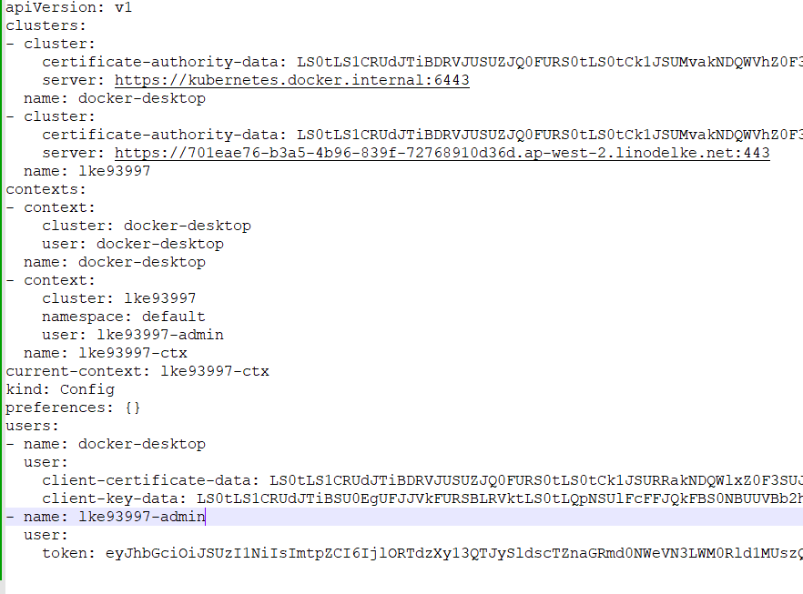

**Once we create a cluster:**

* Just copy paste the context,user,cluster info in our local config file.
* Once we do that in docker-desktop kubernetes we see 2 context.
* Once we switch the context and do Kubectl get nodes we get 3 nodes of our cloud cluster in Kubectl command.

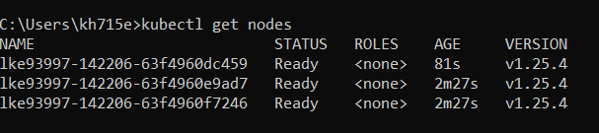

**PODS**

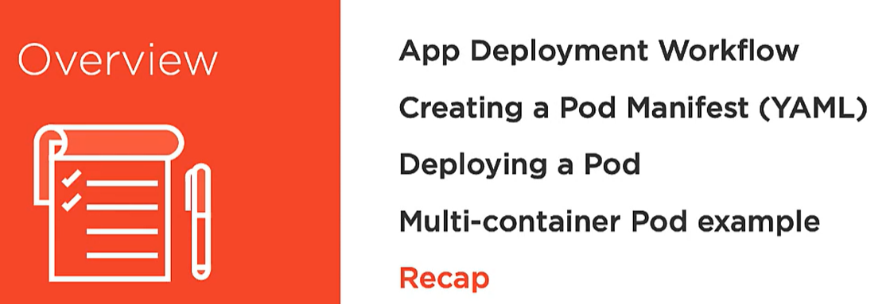



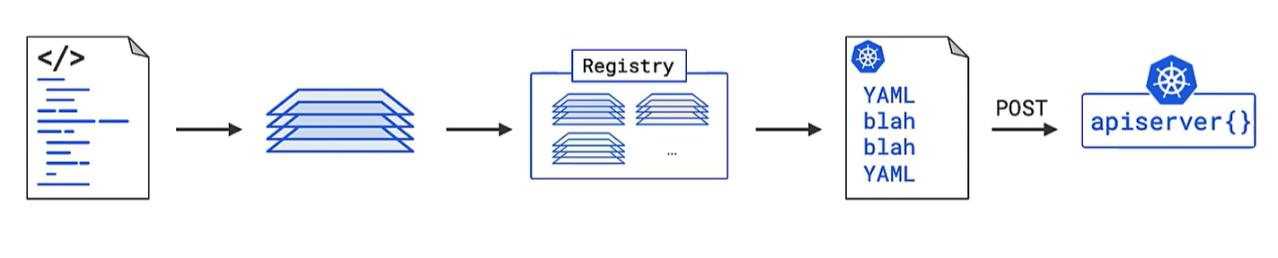

* We have an app code and its dependencies.
* We build an image out of it using Dockerfile.
* Once image is build we register the image to dockerhub.
* Then we create a manifest file where we define all our app state and POST it to apiserver of our cluster.
* Then K8s does the rest.

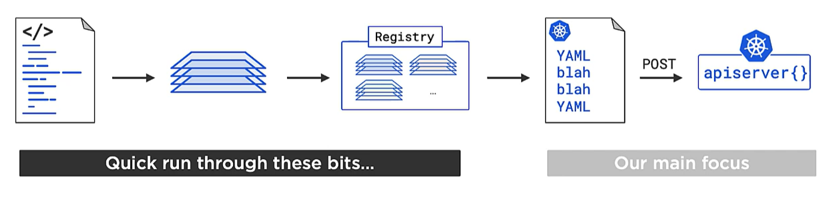

* So we clone an App code from <https://github.com/nigelpoulton/getting-started-k8s> and we will build our dockerfile.
* We build an image out of dockerfile



* We push the image on registry

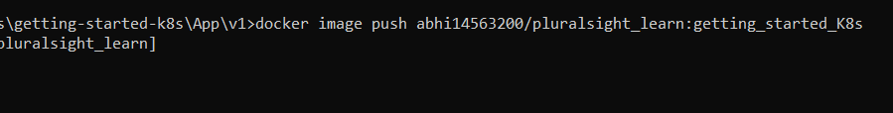

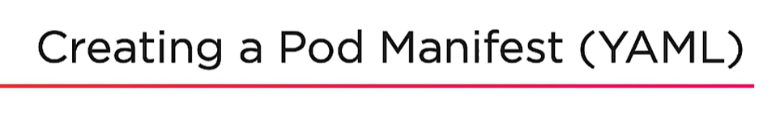

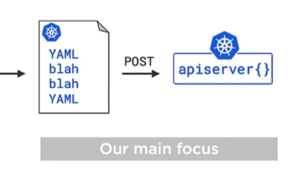

Now we define declaratively what and how we want to deploy our apps using standalone PODS.

PODS in K8s are service object with individual API component. We post to Apiserver which acts as intermediate for us to talk to PODS api.

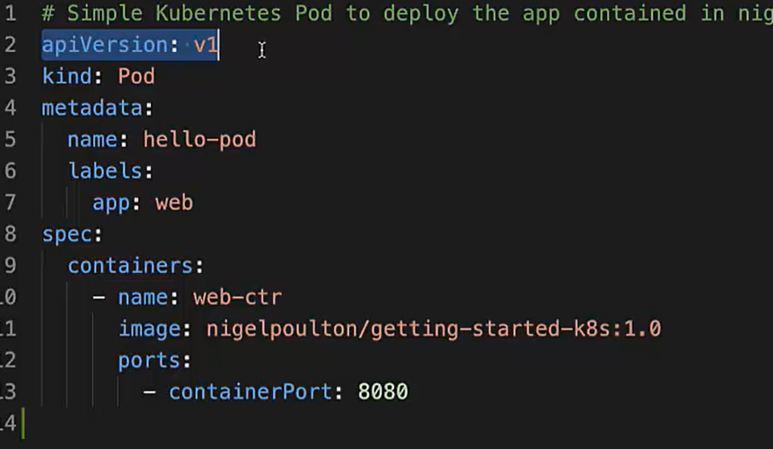

apiVersion: v1 means it’s a stable version.

**Alpha** – for testing and prototyping.

**Beta**- more stable than alpha.

**GA/Stable** – ready for production.

**VERSION and Sub-Groups**

* Each service object in K8s have their own API component and they are grouped also in sub-groups.
* **Deploy** service object is grouped in **API** sub-group and version v1.

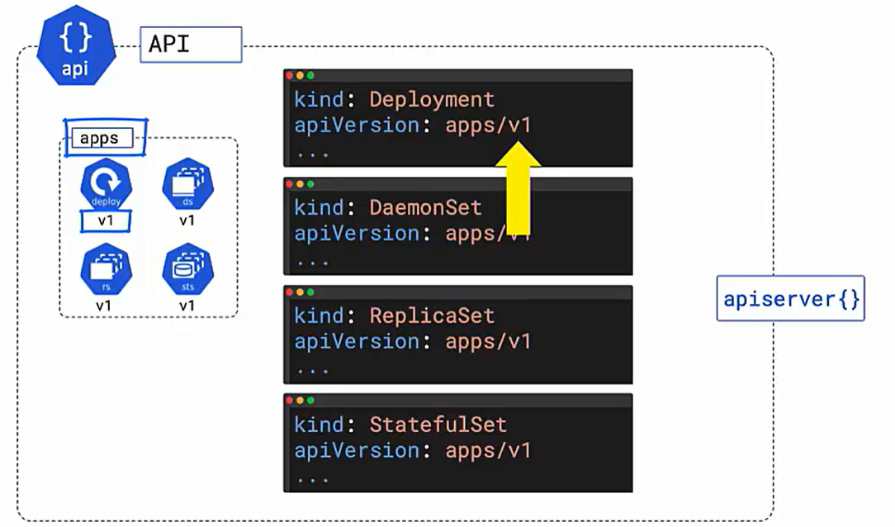

* Cron job objects are in **batch** api sub-group.
* SIMILAR OBJECTS ARE GROUPED TOGETHER TO PARTITION THE APIs in K8s.
* Core group APIs
* PODs are in **core** group in v1 version and we don’t need any subgroup name for that, it is defined directly like

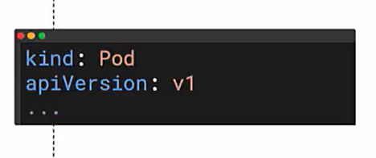

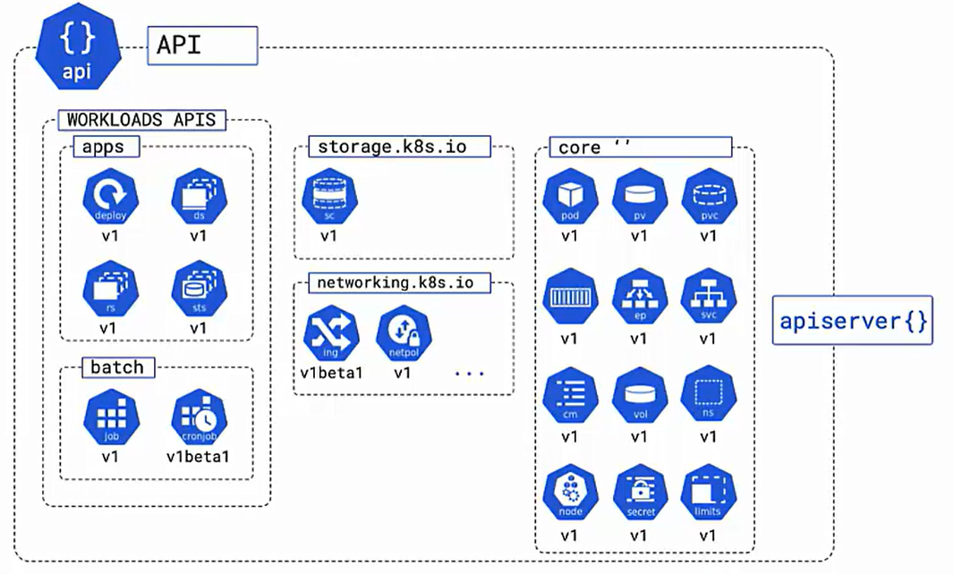

**POD OBJECT DEFINITION**

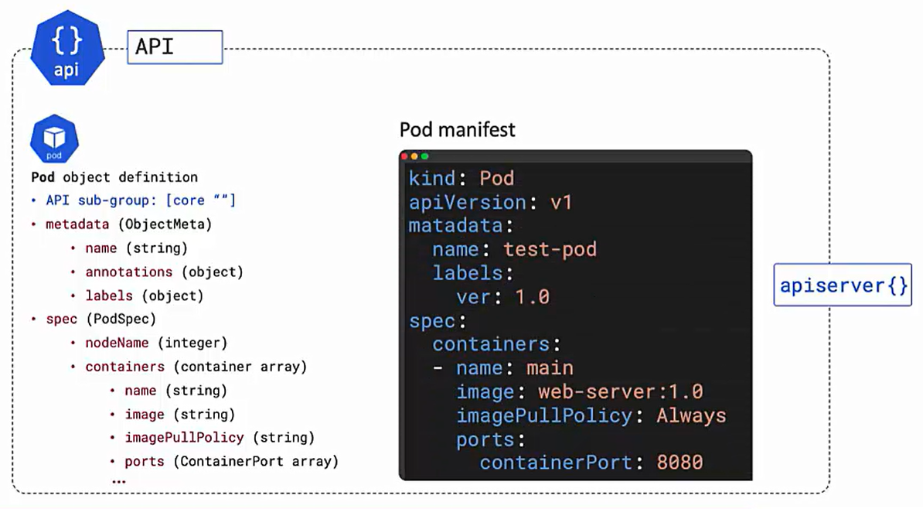

**POD.yml**

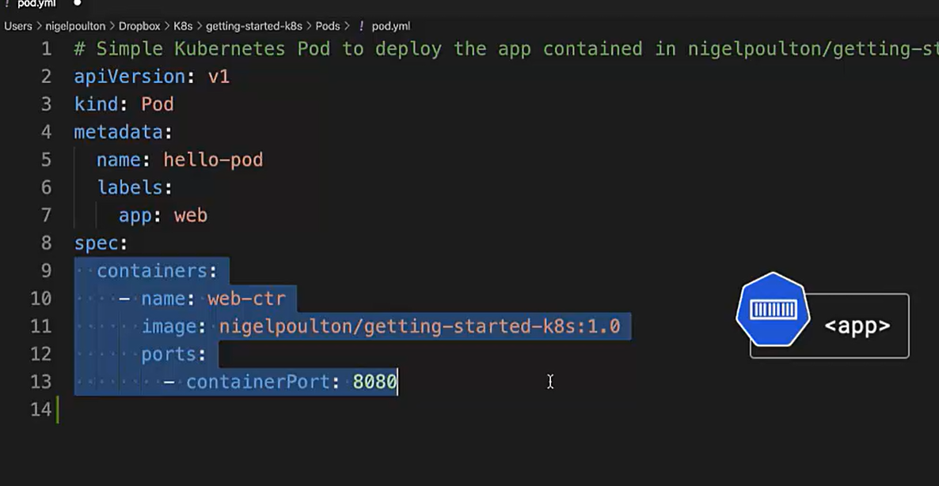

We have our app running in container with the help of code from 9-13 and we are wrapper this container with a thin layer of PODs ( which provide metadata to our apps)

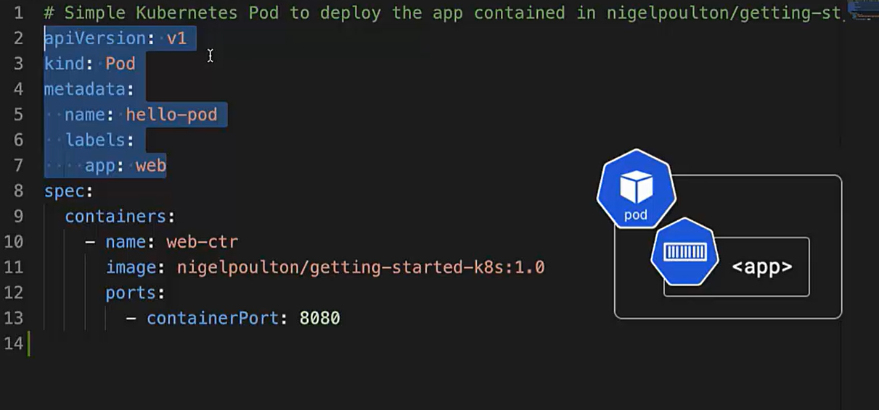

**DEPLOY PODS**

1. Go to the directory where our pod.yml is and then run

**Kubectl apply -f pod.yml**

1. Kubectl will post this to apiserver then request is authenticated and authorize
2. configs get stored in cluster store.
3. scheduler will then assign the Pod to a node.

**Kubectl get nodes –watch**

**Kubectl get nodes -o wide**

**Kubectl describe pods hello-pod**

It will show state of nodes, starting or running

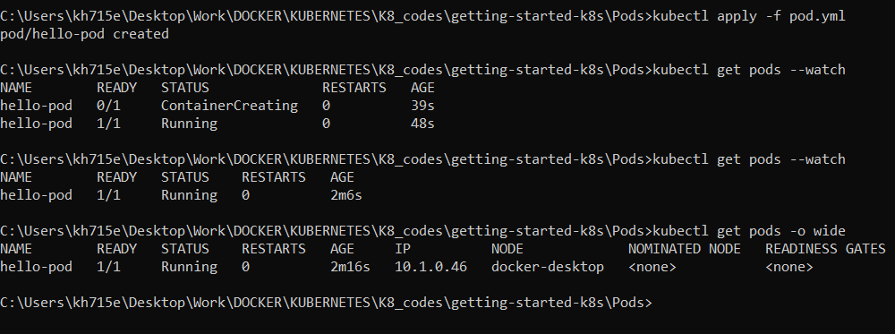

**PODS ARE OUR APPS AND NODES (WINDOWS OR LINUX) ARE OUR INFRASTRUCTURE.**

**Multi-Container PODS**

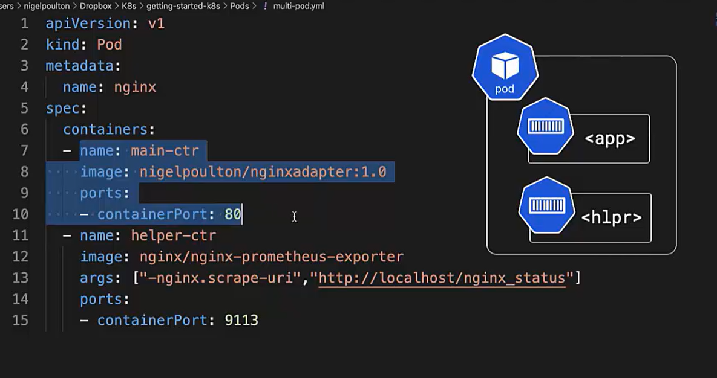

* Both containers are listening on different ports.
* If main container needs to talk to helper it will do on localhost:9113 and vice-versa on localhost:80
* Both containers will deploy to same node

**Why we need helper container(side-car) here?**

* Main container is running a nginx apps.
* Helper container is taking the logs of main container and exposing it to 3rd party app Prometheus.
* Prometheus running in some other place in cluster can’t read nginx logs so helper container that watches nginx logs and expose to format Prometheus likes.

**K8s Networking with Services**

How we can expose apps within cluster and outside world with the help of K8 service object.

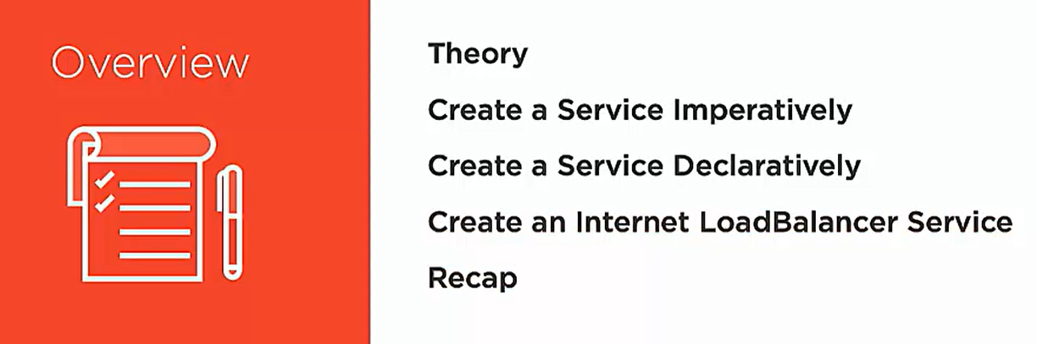

SERVICES THEORY



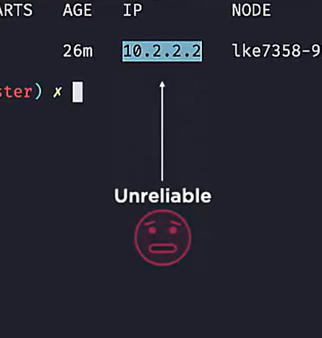

* When we create a Pod it is assigned with an IP address but this IP is Pods IP in cluster.
* Outside world is not part of the cluster so it is not aware about this IP.
* Pods can die and new Pods with new IP can be created by controller.
* So how outside world and internal cluster can interact with our apps inside Pods?

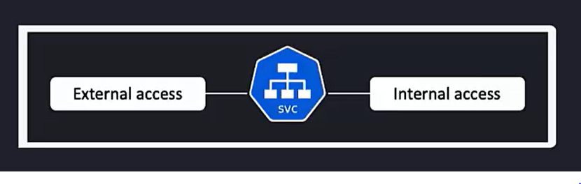

**Services helps in both external access as well as internal access.**

**How to connect TO OUR APPS** 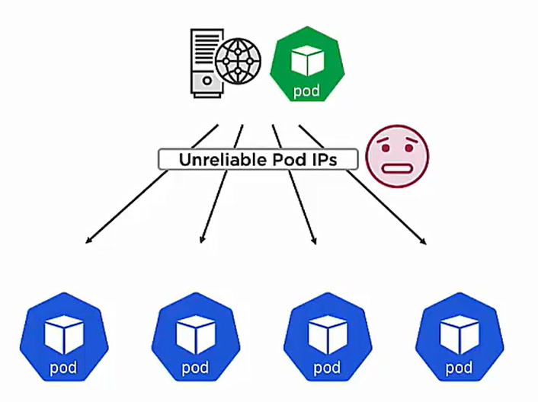

We have bunch of Pods in the cluster so outside world or other pods in the cluster can’t directly connect to them with the pods IP cause pods are mutable.

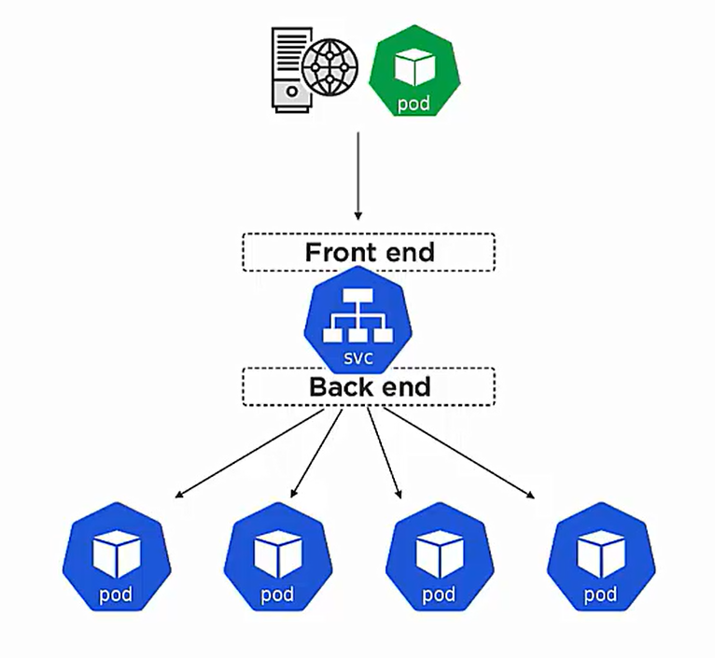

* So, we have service object as an interface between external world or other pods in cluster and pods.
* It has front end which provides stable IP and DNS name to the world.
* It has backend job which decides which pods traffic needs to redirect.

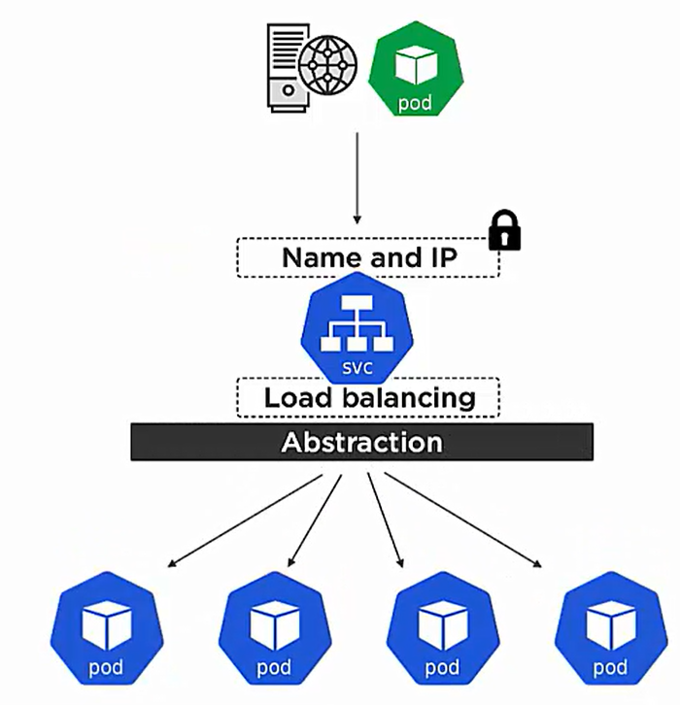

Pods can come and go but the IP and DNS name in front end never change.

* Kubernetes automatically assigns IP to each services and its called cluster IP only used within cluster.
* It is a control plane feature . Everytime a new services comes to apiserver its name is registered in cluster DNS against the cluster IP.
* All container and pods knows about the cluster DNS.

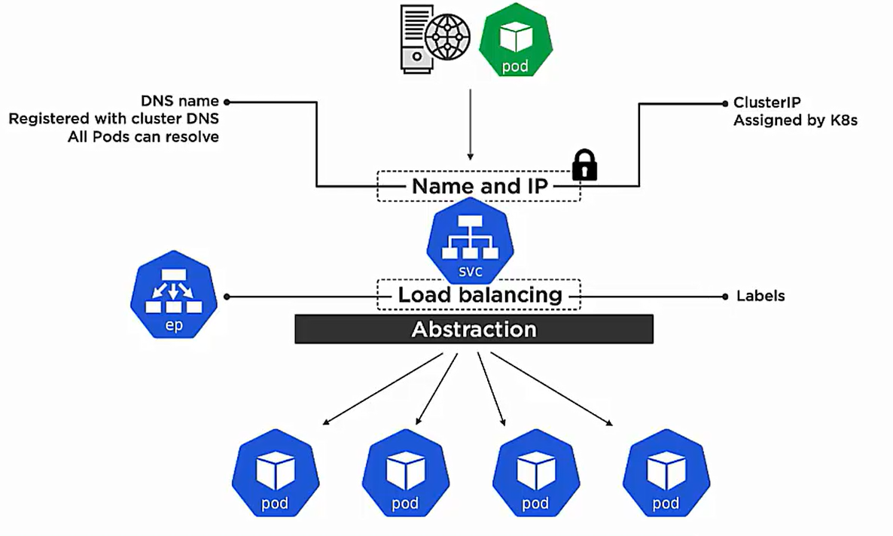

**HOW PODS inside cluster talks to other PODS?**

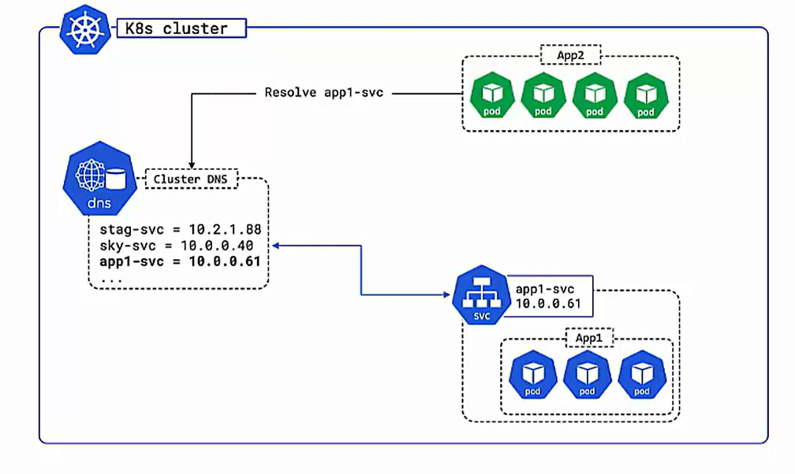

* Each service is assigned with an IP by K8s.
* When service comes to apiserver then service name is registered with cluster DNS against the IP assigned to it.
* Every Pod has access to the cluster DNS.
* Now Pod know about the service name so it request the cluster DNS with service name and get backs its IP and then communicate.

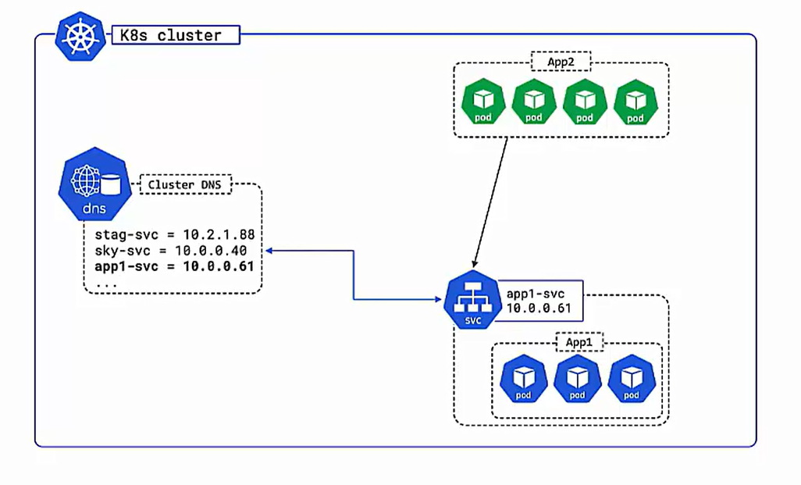

**HOW EXTERNAL WORLD CONNECTS TO PODS?**

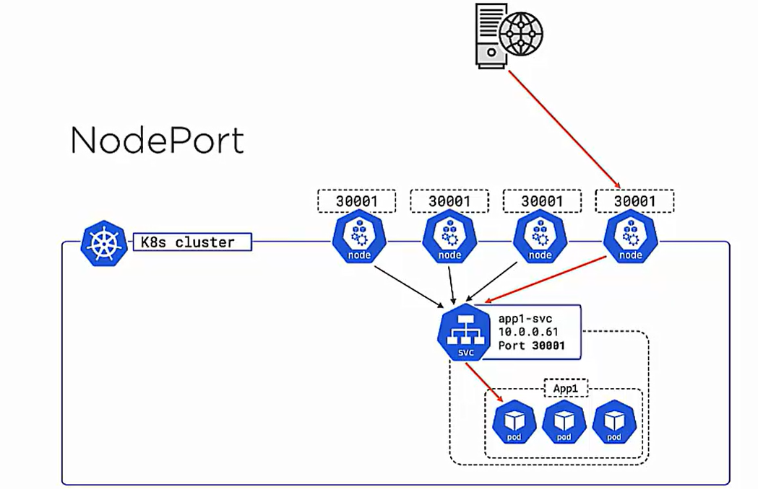

* Each service gets a network port too.
* Network port is mapped to each node in the cluster.
* So, from outside world we can send request to any node on the port and node can map to service and eventually to the POD.

**LOAD BALANCER**

It is integrated to cloud provider load balancer and K8s does all work.

We just have to give the type and K8s does all work.

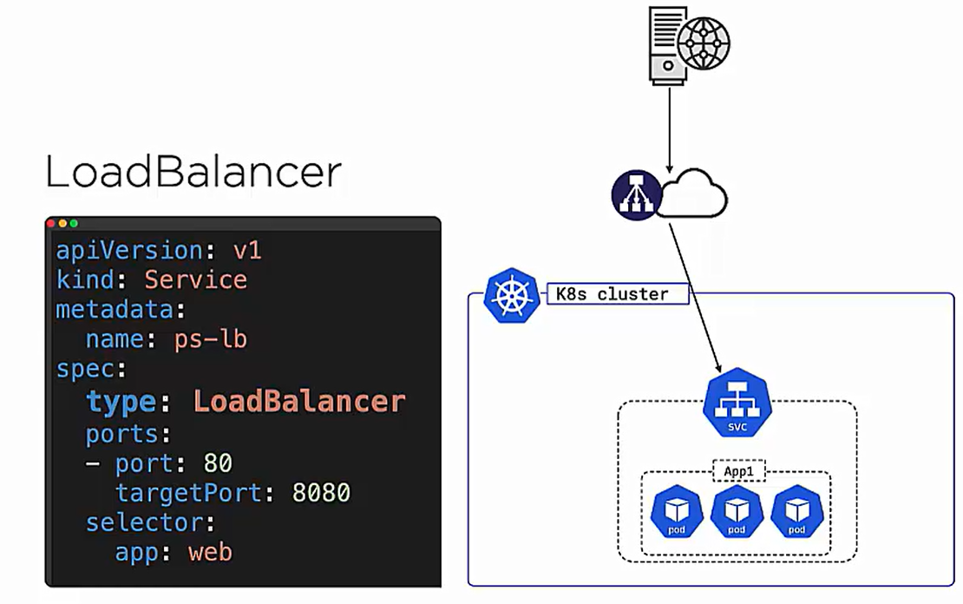

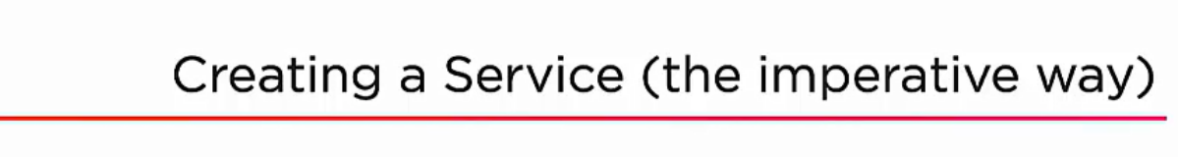

Just creating pods will not expose the apps cause we cannot trust pods IP , so we have to wrap pods with some services to connect to our apps.

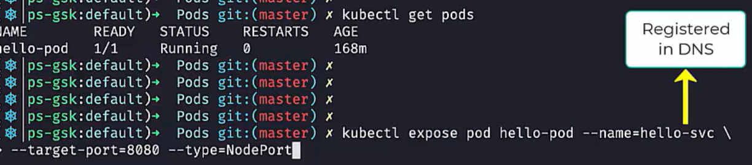

--name = name of service registered with cluster DNS.

--target = it is the port cluster is listening to.

--type = NodePort (all nodes in the cluster is aware about it )

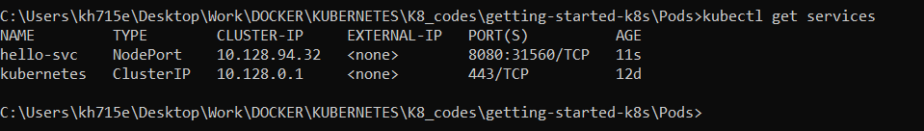

Kubernetes is the system svc that exposes IP of service within cluster.

hello-svc is the service exposed.

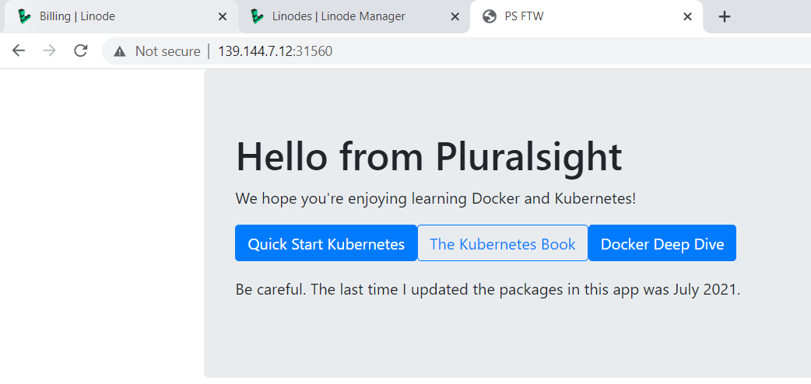

Now we can use IP of each node and the nodeport to launch the webservice.

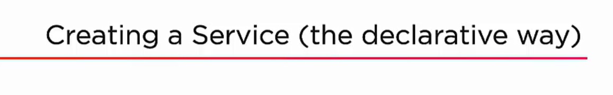

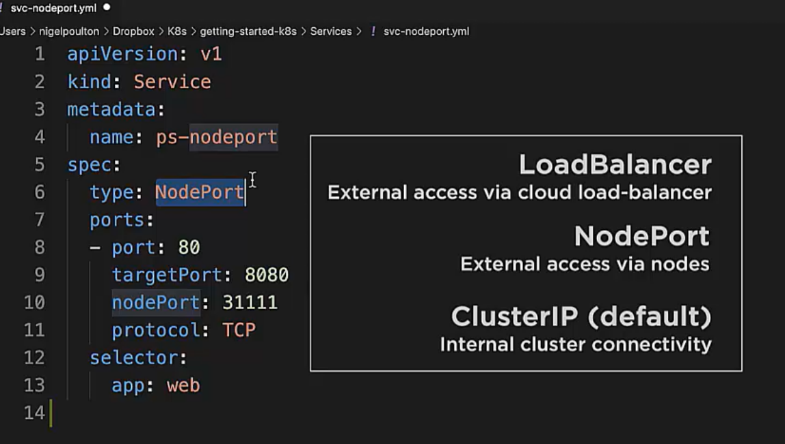

**ClusterIP** – Each service is assigned with a Cluster IP which is registered with cluster DNS but it is only used **within cluster.**

**NodePort –** It takes the cluster IP and add TCP/UDP port on top of it and make it available to all nodes. But we need to remember the nodes IP and port.

**Loadbalancer-** Build on top of clusterIP and nodeport and integrate with cloud provider load balancer.

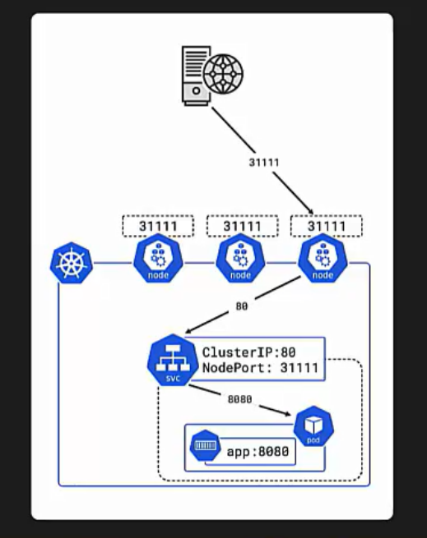

**Port : 80 –** port value which services listens to inside cluster. It is tie to cluster IP. If any other services are registered with same DNS name it is the port which will help to access particular service.

**targetPort : 8080 –** port value which apps listen inside container.

**nodePort** – It is port value which is mapped to every cluster node.

Selector:

**app**: **web** is the list of labels of pods

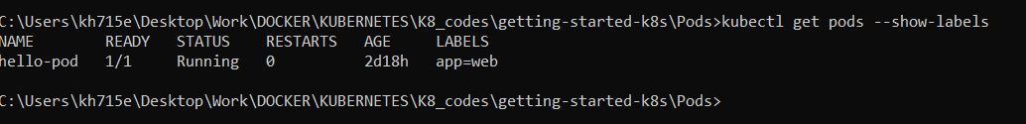

Command to run a nodeport service

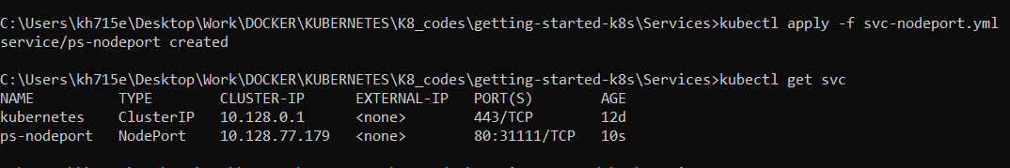

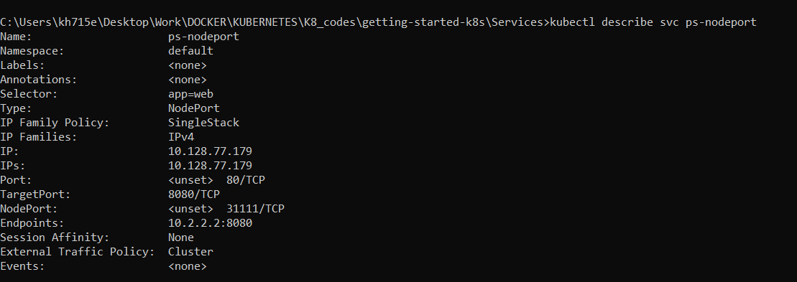

**Endpoints** – list of healthy pods request will be directed.



It will only work in cloud platform not in docker -desktop

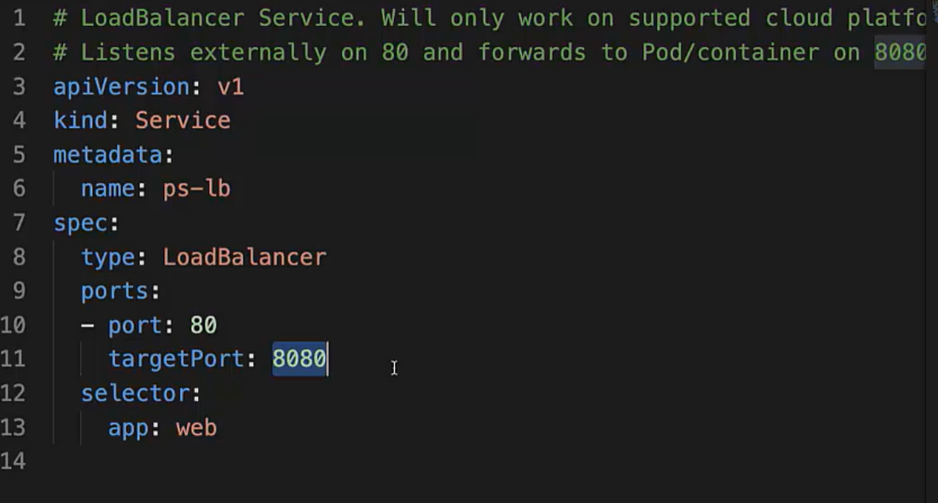

First we have no loadbalancer in our cloud.

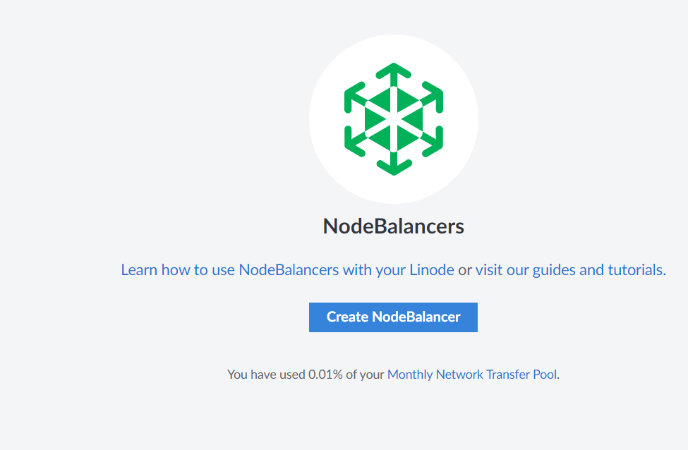

When we run **Kubectl apply -f svc-lb.yml** then kubernetes talks to cloud provider load balancer and create on public IP.

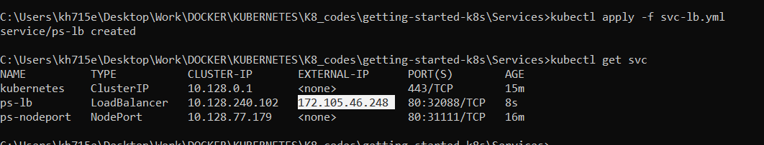

Now we have a nodebalancer in cloud listening to port:80 .

**THIS PORT 80 is the service port which is listening.**

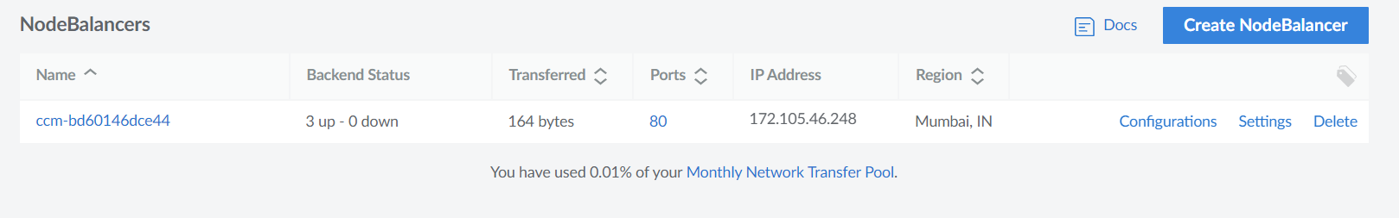

When we hit 172.105.46.248 then traffic comes to our any node in cluster and it has **nodeports** which route it to cluster IP at port 80 and then it route again to port 8080.

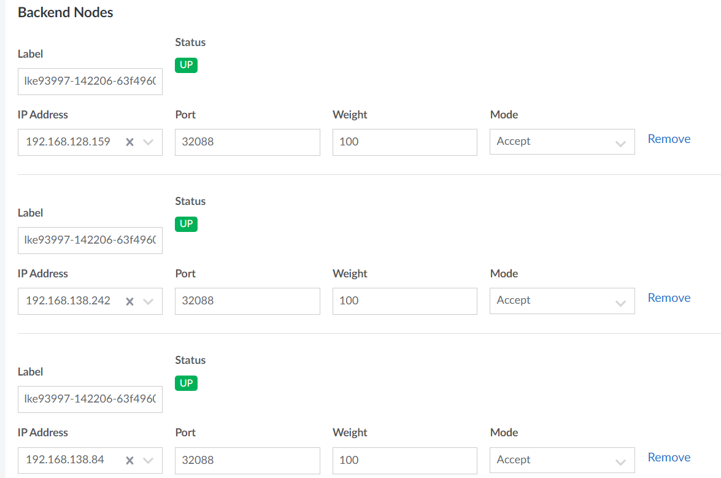

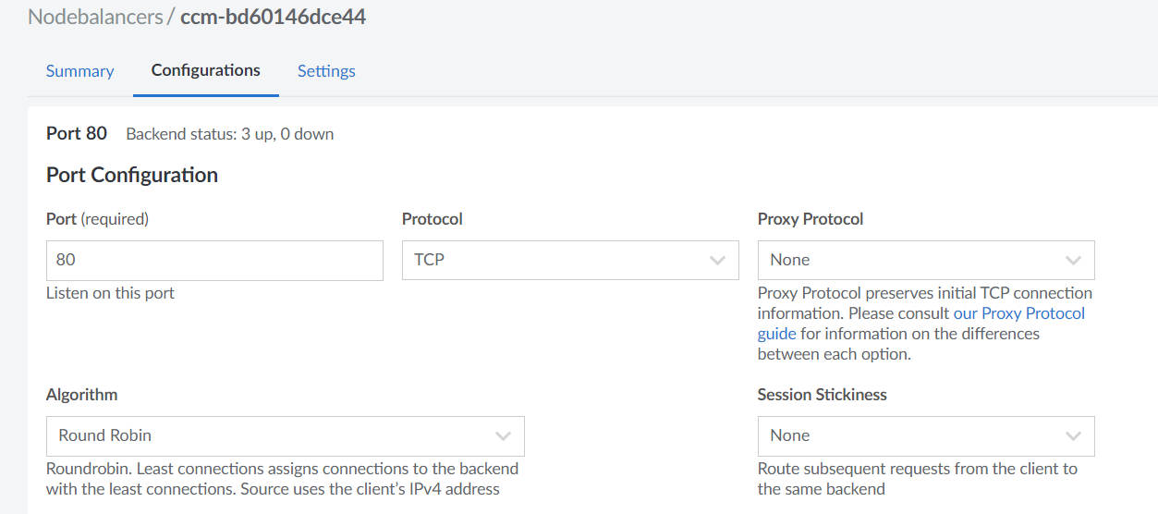

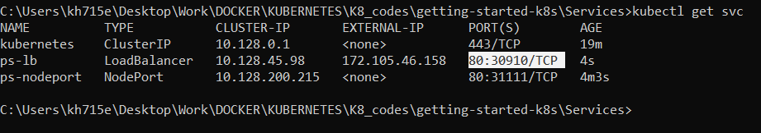

NOW WE CAN ACCESS OUR APP USING 3 ways:

* [http://170.187.251.14:**31111**/](http://170.187.251.14:31111/) [ created during nodeport]
* [http://170.187.251.14:**30910**/](http://170.187.251.14:30910/) [ it’s a node port created during lb]
* <http://172.105.46.158/> [it’s a external IP created during lb]

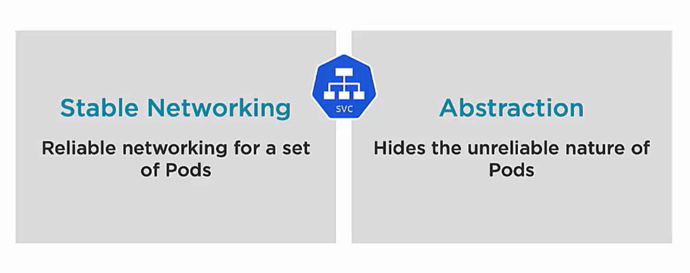

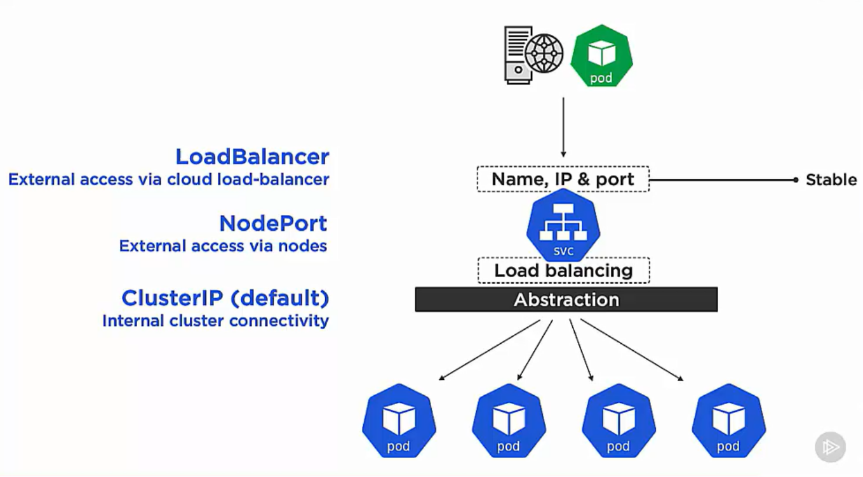

**K8s deployments**

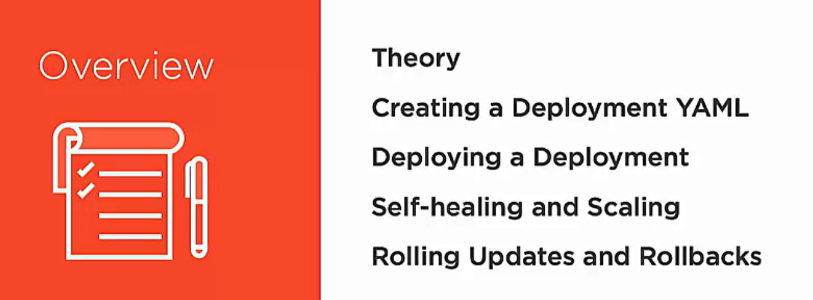

**Deploy** is an object in k8s api in **apps** sub-group

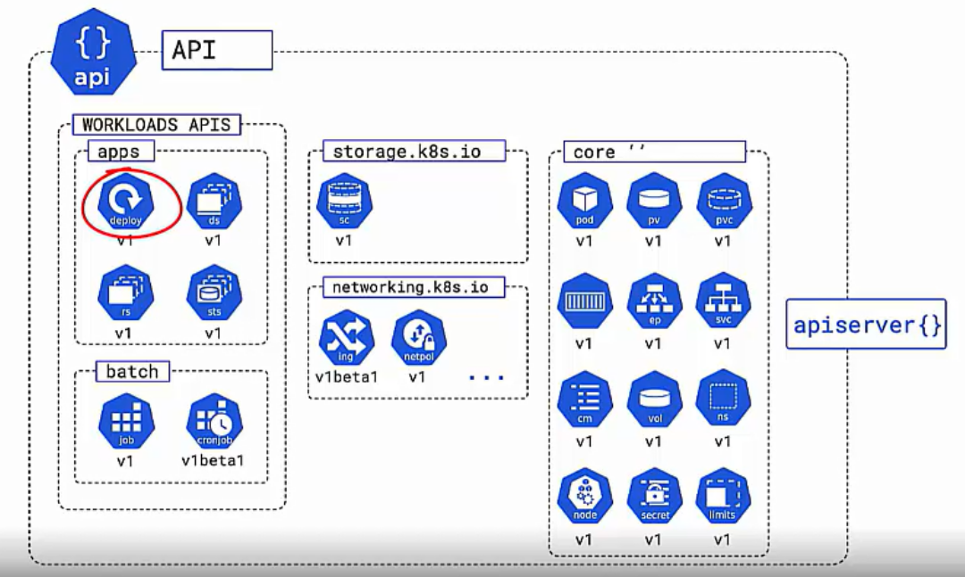

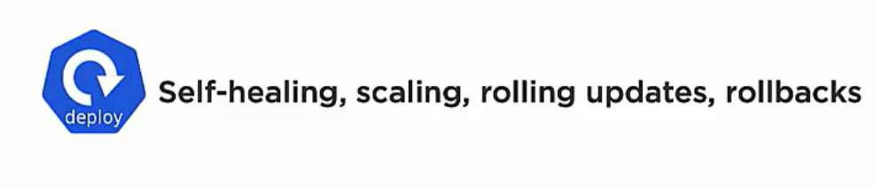

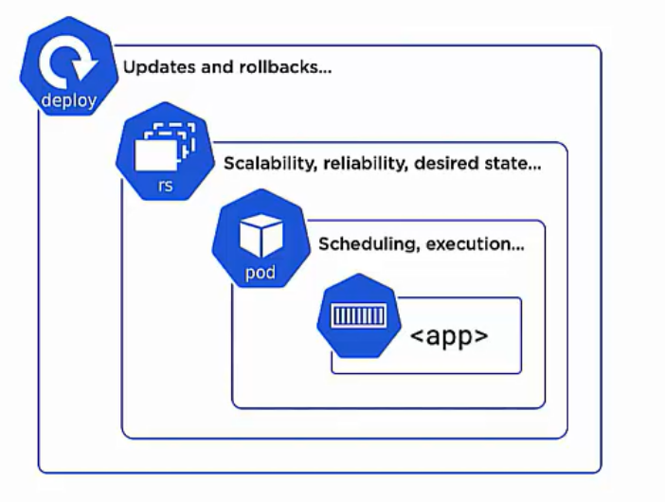

It is the replica set controller which does the scaling and reconcile loop which watches the observed and desired state.

But in actual deploy takes care of replica set.

**HOW IT WORKS?**

* We create a deploy yml file with the desired state of the app.
* It goes to apiserver where auth and athn happens and desired state gets stored in the cluster store.
* Now the scheduler will create 5 pods in the nodes.
* Now the replica set keeps watching the cluster for 5 nodes of the dersired state.

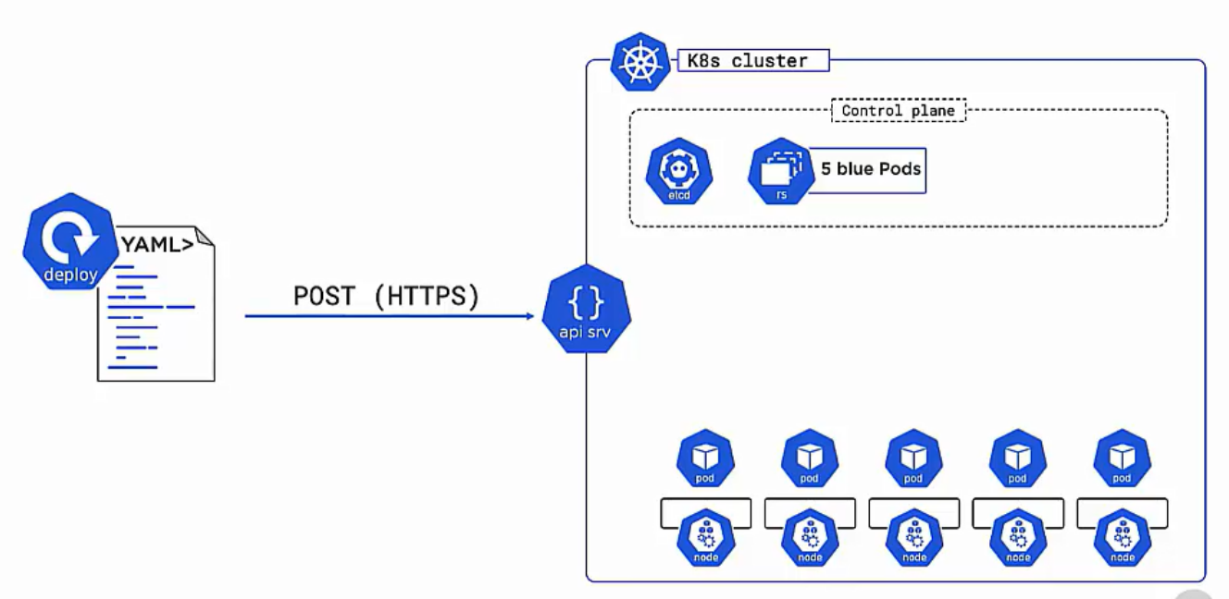

**WHAT HAPPENS WHEN WE DO SOME CHANGES TO THE IMAGE?**

* We make the some change in the yml file and post it to the api-server.
* K8s will create new replica set with new version.
* K8s then winds older pods and create a new pods one at a time. [Rolling update]
* The old version of replica set is not deleted while its not managing any pods but they still exist if we have to roll-back to previous version.

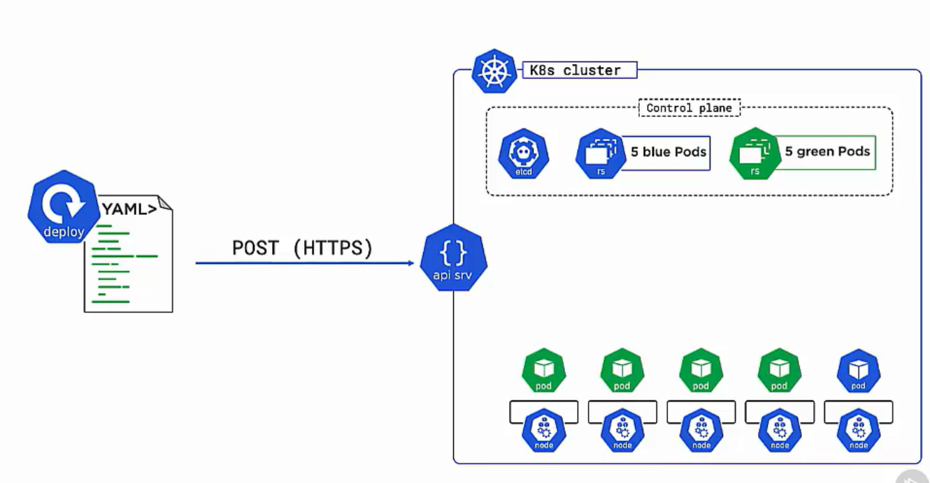

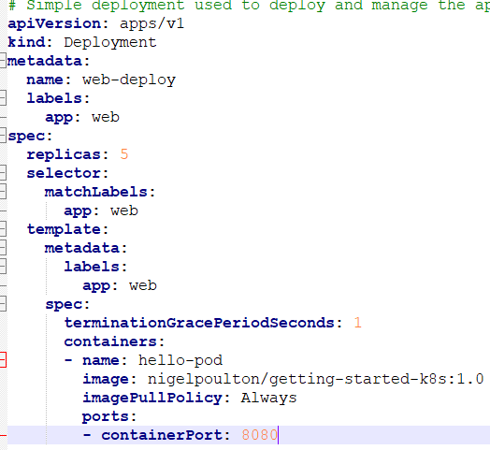

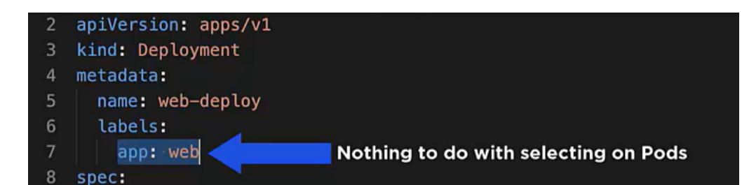

**CONTAINER SECTION**

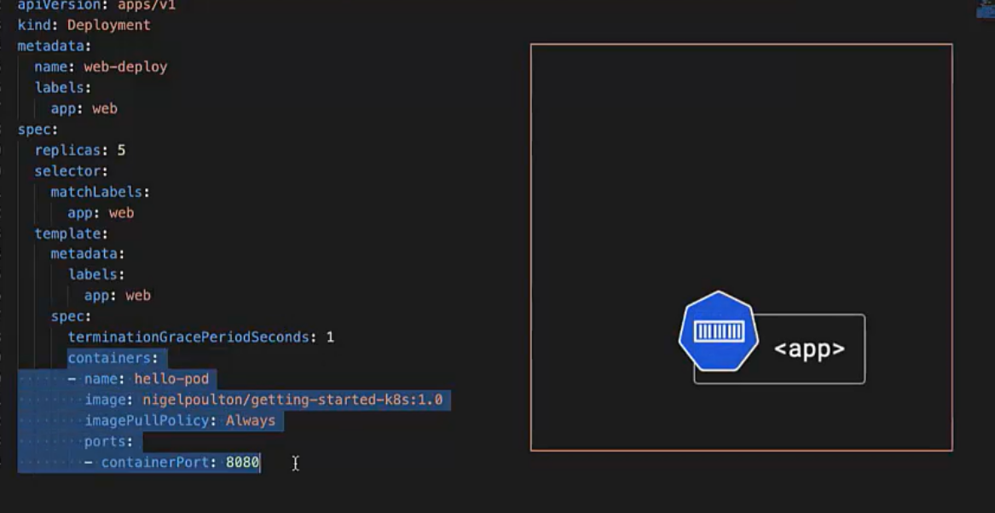

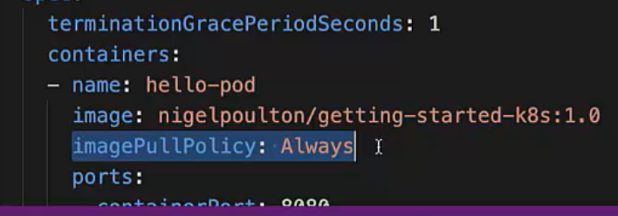

Here we are telling K8s to always pull from registry and not look for local copy of images.

**POD SPEC**

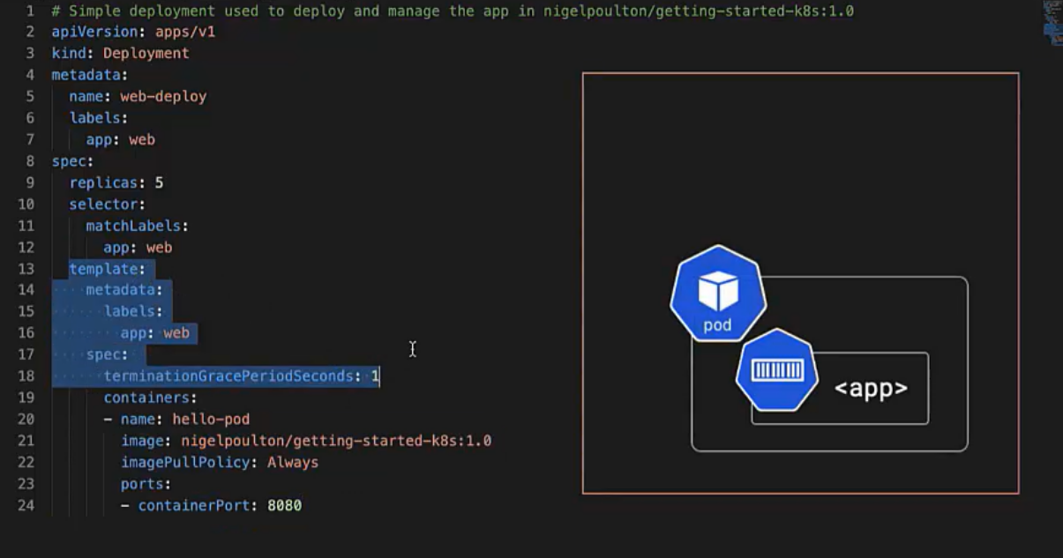

**DEPLOY SPEC**

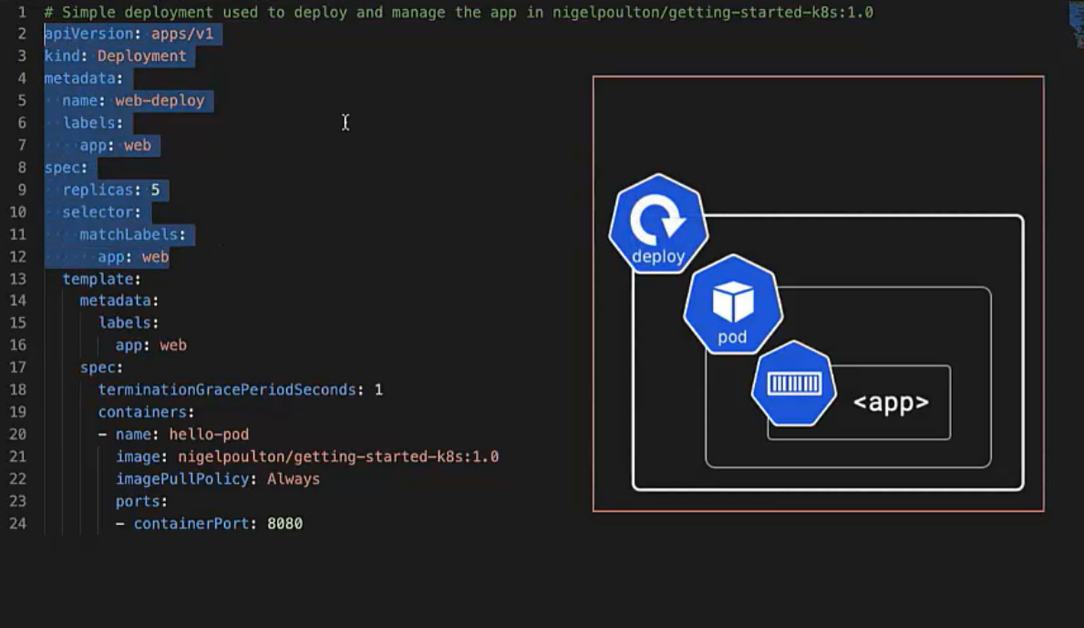

The **label selector in deployment** spec must **match** with **label selector in pod spec**. So, the deploy object is aware that which pods its managing.

When we run **Kubectl apply -f deploy.yml**

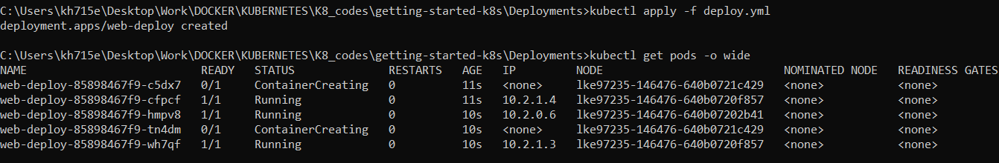

**5 pods are running on 3 nodes**.’

We can check the deploy and replica set as well

Kubectl get deploy

Kubectl get replicaset

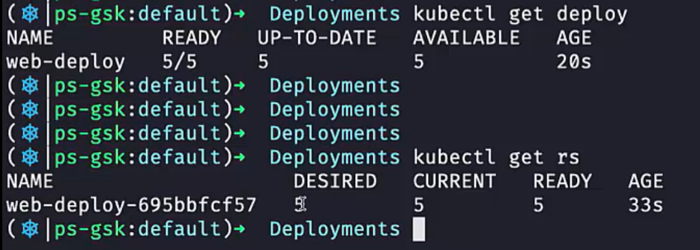

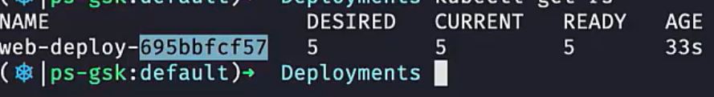

Web-deploy is the name of deploy and 695bbfcf57 is the crypto has of pod.

We create 5 replicas pods of our image and using deploy we are managing those pods.

**BUT ARE WE ABLE TO ACCESS THESE PODS FROM OUTSIDE?**

* To access pods we need service object which we already created before creating any pods.

**BUT HOW DOES EXISTING SERVICE CONNECT TO NEW PODS?**

* **Services are always looking at api-server for new pods with same label as described in service.**
* **If label matches services then adds that pod to its endpoint list.**
* When we describe our svc

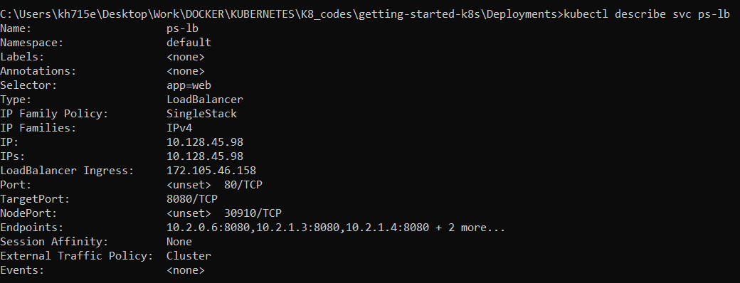

* It has a selector label as app=web
* When we see labels for pods it’s the same

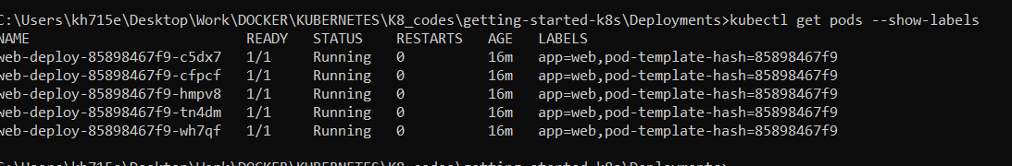

* **So first the labels matches and then services will add the 5 IP of pods to its endpoints.**

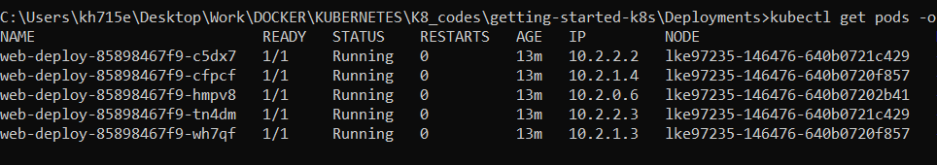

**Kubectl describe ep ps-lb**

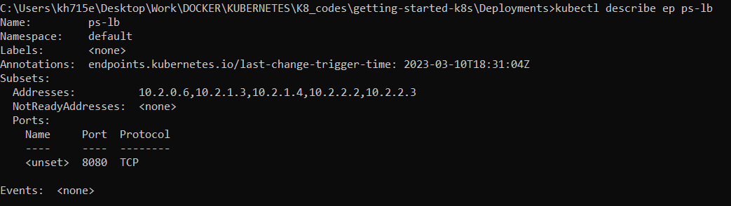

**WE SEE IP OF ALL 5 PODS ARE ADDED AUTOMATICALLY TO THE SERVICES ENDPOINTS. NOW SERVICES WILL LOAD BALANCE TRAFFIC TOWARDS THESE 5 PODS.**

**SELF-HEALING AND SCALING**

**We deployed our app with 5 replica pods.**

* **What if 1 pod goes down?**

So, the deploy and replica controller will make sure that desired and current state matches. So it will start a brand new pods.

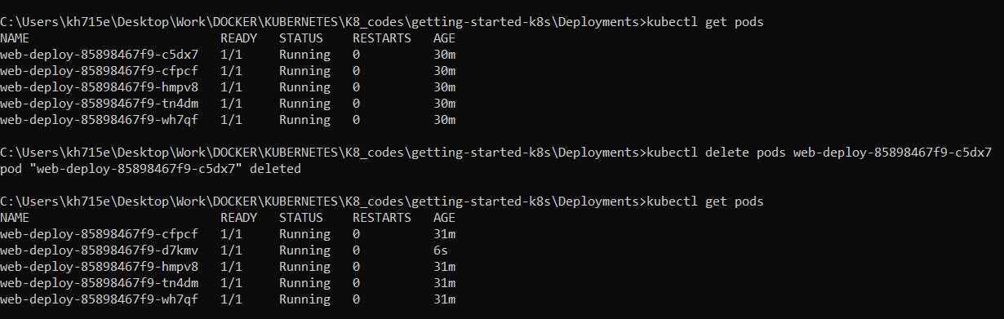

* **What if 1 node in which pods are running goes down?**

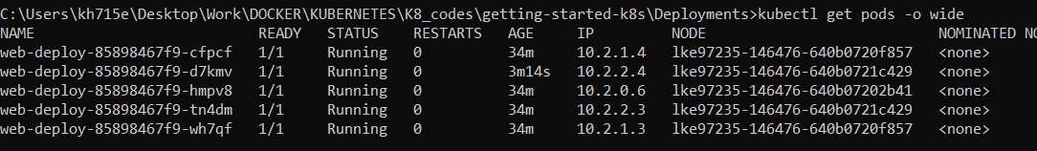

**We can see 2 pods are running on node ending ……..429**

**What if we delete the node?**

**For a moment till K8s bring the desired state of 3 nodes we have 2 running nodes**

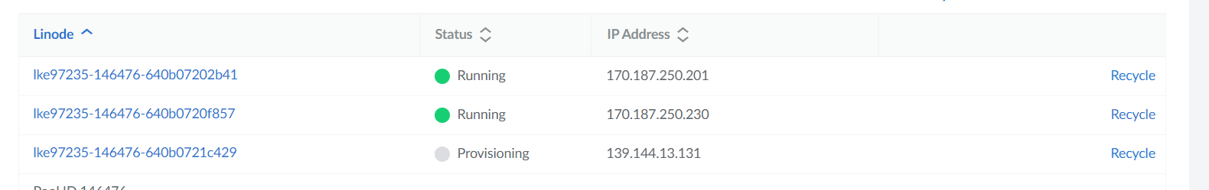

**We see we still have 5 pods running but on 2 nodes only**

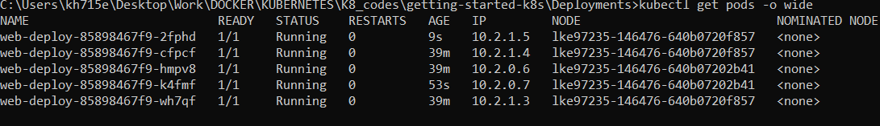

**So all time the replica set will match the desired state with observed state.**

1. **What if we want to scale the pods by needing more replicas?**

* We go to the deploy.yml and change the replica value.
* We again post the yml to cluster and replica set controller will see the desired state of pods in cluster store and runs new pods

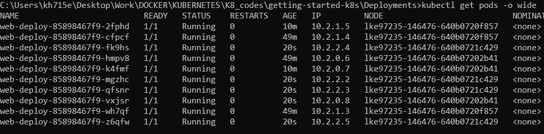

We get 10 pods load balance amount all 3 nodes.

We can also scale things down.



We can scale things based on needs by providing limits.

**ROLLING UPDATES AND VERSION ROLLBACKS**

Rolling updates means when we change anything in our container spec either (anything in image or image name or ports etc etc), instead of deleting older pods and creating new ones. Why not we do roll updates pods one by one.

We do this by

**Strategy:**

**Type:RollingUpdate**

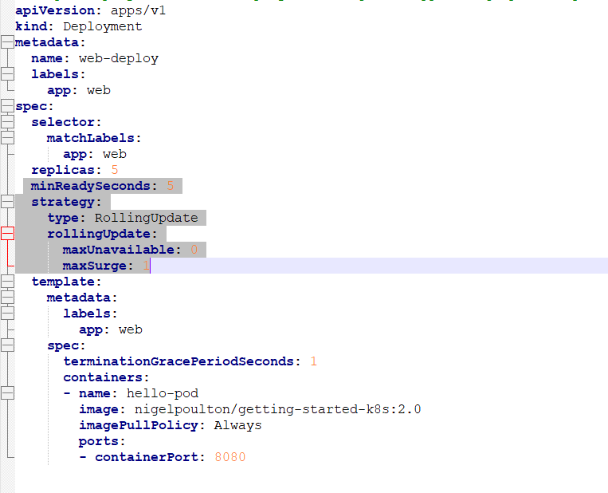

**maxUnavailable:0** [means during update at any time pods size should never less than 10]

**maxSurge: 1** [means just during update we can have pods 11 also by just during updates]

**minReadySecond:5** [means K8s will create a new pod with new version and make pod size as 11 for just 5 sec and then it delete 1 older pods and repeat the process until it cycle towards all pods]

**DEMO**

We change the name of the image

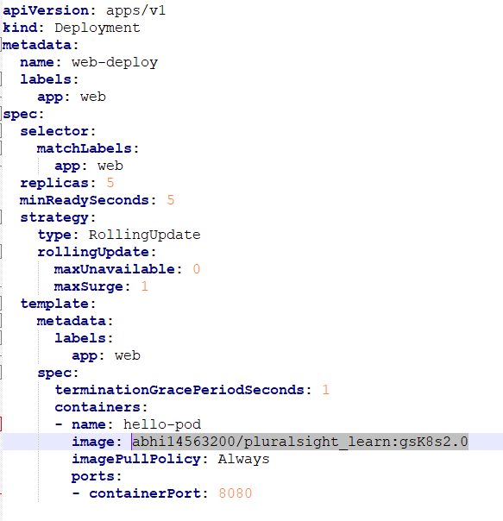

**Once we post the yml we can watch the status of pods.**

**1 new pod with new version is created and then we wait for 5 sec and delete 1 older pods and this process keeps on.**

**RUN BOTH COMMAND PARALLEL TO SEE STATUS AND PODS**

* **Kubectl get pods –watch**
* **Kubectl rollout status deploy deploy-web**

**If we face issue in rolling update that means our new version image is not pushed to registry.**

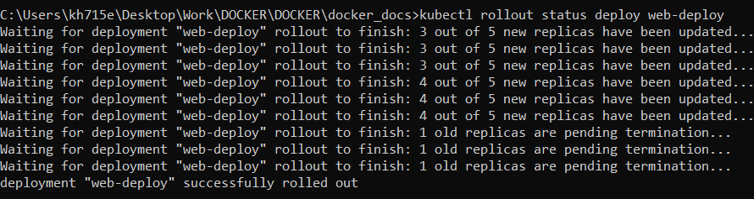

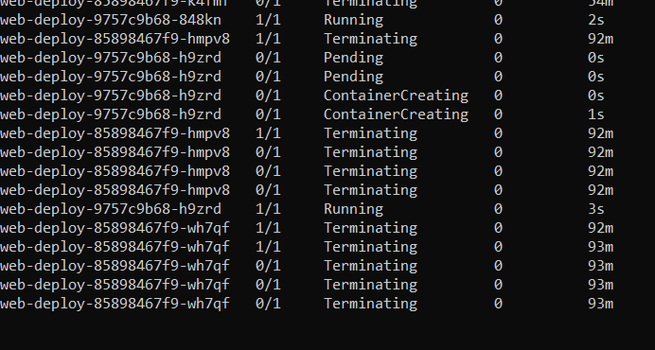

**WE WILL SEE THE APP GOT CHANGED.**

**ROLLBACKS**

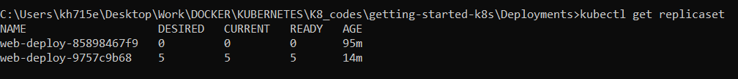

We see currently we have 2 replicaset one with new version managing 5 pods and other with old version managing 0 pods.

When we describe old replicaset it will show which image version is was managing pods of

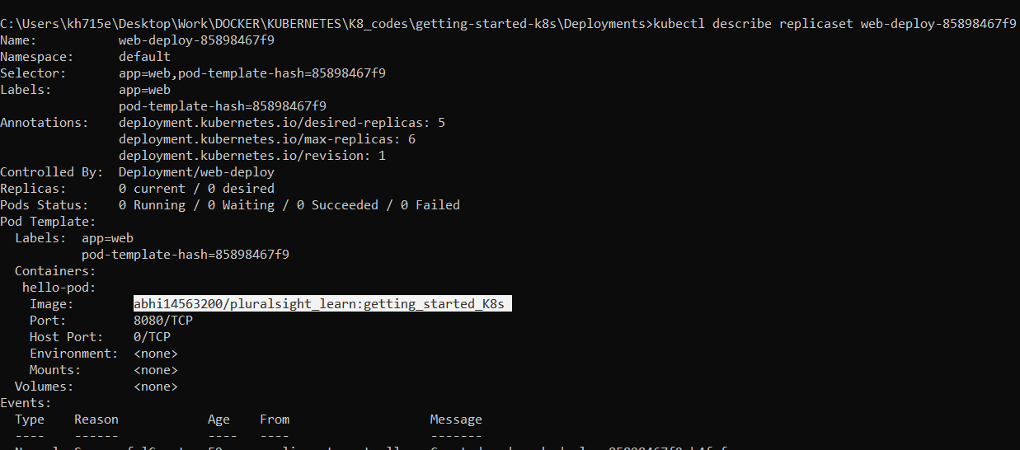

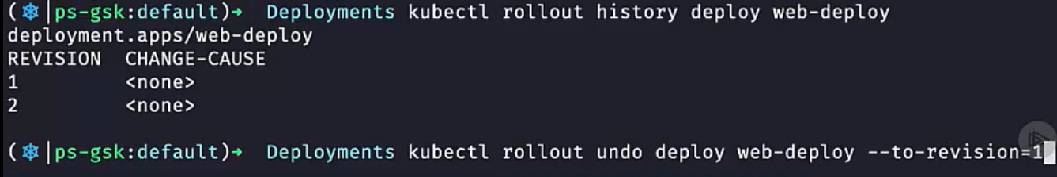

We can go back to previous version of image by doing

**Kubectl rollout undo deploy web-deploy –to-revision=1**

It will again create 1 pod with older version and make pods size 6 and wait for 5 second and delete the 1 new version pod and repeat for 5 pods.

NOW OUR ORIGINAL VERSION APP IS DEPLOYED ROLLEDBACK

**NOW WE SEE HISTORY**

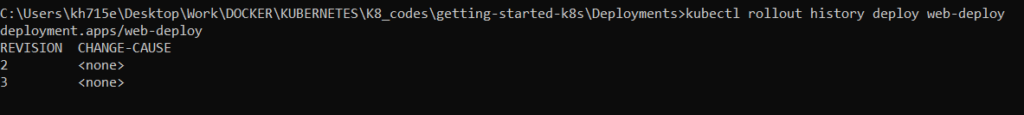

**Now replicaset will be reversed**

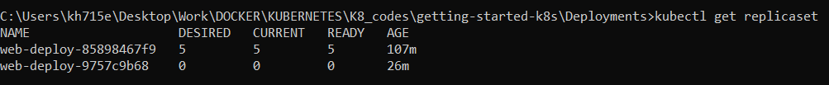

**NEXT**

